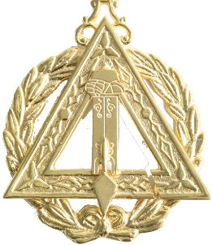
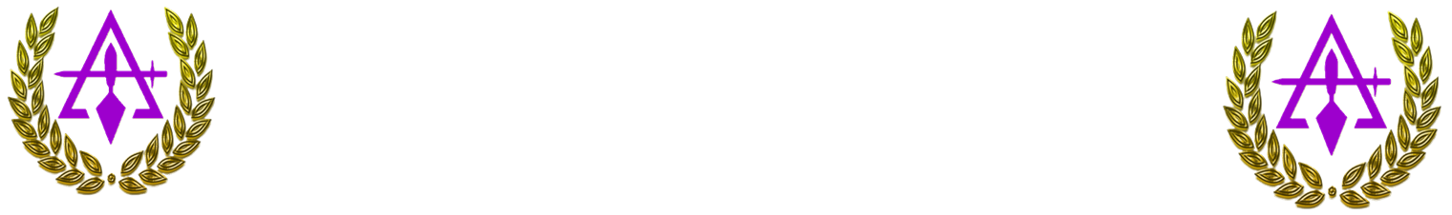
Office of the R.I. Grand Principal Conductor of the Works
Alpha Omega Illustrious Grand Council, Royal and Select Masters
Washington and Jurisdiction, PHA

July 2025 – June 2026
Subject: Annual Report of Grand Principal Conductor of the Works
To: Most Illustrious Grand Thrice Illustrious Master, Deputy Grand TIM, Grand Captain of the Guard, Grand Council Officers, Thrice Illustrious Masters, Principal Conductor of the Works, Captains of the Guard, and all Royal Select Masters of Washington and Jurisdiction

May the Supreme Architect of the Universe continue to bless you all, your families, and our Cryptic Rite with a lifetime of shared successes, happiness, love, and peace. It is with the utmost respect, fraternal devotion, and solemn duty that I present this Annual Report of the Office of Grand Principal of the Works to the Most Illustrious Grand Thrice Illustrious Master, the Deputy Grand TIM, Grand Council Officers and the assembled members of the Cryptic Rite in the Jurisdiction of Washington. This report delineates the activities, accomplishments, and initiatives undertaken by my office during the past Masonic year, reflecting a steadfast commitment to ritual integrity, instructional excellence, and the advancement of subordinate Councils.
Article III - DUTIES OF THE GRAND COUNCIL OFFICERS, of the Alpha and Omega Illustrious Grand Council Constitutions and By-Laws
Duties of the Right Illustrious Grand Principal Conductor of the Works
Section 1. It shall be the duty of the R.I. Grand Principal Conductor of the Works:
- To assist the Most Illustrious Grand Thrice Illustrious Master in the various duties of his office and shall perform such duties as may be assigned to him by the Most Illustrious Grand Thrice Illustrious Master
- To supervise all special programs of the Grand Council.
Section 2. In the event of the death, absence, removal from the jurisdiction or inability to serve of the Most Illustrious Grand Thrice Illustrious Master and of the R.I. Deputy Grand Thrice Illustrious Master, he shall succeed to the duties of the Most Illustrious Grand Thrice Illustrious Master and shall act as the Most Illustrious Grand Thrice Illustrious Master Pro Tem with full power and authority in his place until the condition or circumstance is removed or until the next regular Grand Assembly of this Grand Council.

1. Attendance and Official Engagements
- Grand Council Assemblies or meetings Attended: [Insert Number]
The foregoing engagements underscore the office’s unwavering dedication to the principles and obligations of our Cryptic Rite and to the support of the Most Illustrious Grand Thrice Illustrious Master.
2. Ritual Oversight and Instruction
- Provided guidance and instruction to subordinate council officers, promoting proficiency and uniformity in ceremonial practices.
- Encouraged adherence to the highest standards of ritual excellence throughout the jurisdiction.
3. Officer Responsibilities and Collaborative Efforts
- Collaborated closely with the Most Illustrious Grand Master, Deputy Grand Masters, and all Grand Council officers in advancing the objectives of the Council.
- Provided counsel and support to subordinate councils in operational and ritual matters.
4. Challenges Encountered and Recommendations
- Challenges Faced During the Year:

- Recommendations for the Coming Masonic Year:

These recommendations are submitted with the purpose of strengthening ritual proficiency, enhancing member participation, and promoting operational excellence throughout the Grand Council.

6. Concluding Statement
In conclusion, the Office of Grand Principal of the Works remains resolute in its commitment to ritual excellence, instruction, and the service of our beloved fraternity. I extend my sincere gratitude to the Most Illustrious Grand Thrice Illustrious Master, Grand Council Officers, and members of the Cryptic Rite in the Jurisdiction of Washington for their guidance, cooperation, and fraternal support during the Masonic year. May the Council continue to flourish in wisdom, service, and fellowship.

Fraternally and Respectfully Submitted,

R.I. Tyrone Cook, KYCH
Grand Principal of the Works
Alpha Omega Illustrious Grand Council
Royal and Select Masters, PHA
Washington and Jurisdiction

